

DEPARTMENT OF COMPUTER SCIENCE AND ENGINEERING

Course: CSE489
Name: Jotee Sarkar Joy
ID: 22301001
Email: jotee.sarkar.joy@g.bracu.ac.bd

Project Title: Retail Shop Management & POS System

Project Features:
By the end of this course, implemented features:

- Role-Based Access Control: Secure multi-tier login system (Admin, Owner, Manager, Staff) with specific dashboard access.
- Product Management: Complete module to add, edit, and manage products, pricing, and stock counts.
- Real-time Inventory Tracking: Automatic deduction of stock levels during transactions and automated stock restoration for voided orders.
- Low-Stock Alerts: Automated dashboard warnings and interactive adjustment sheets when items fall below a specific quantity to prevent stockouts.
- Barcode Scanning: Integration with the device camera to scan retail barcodes, rapidly identifying products and adding them to the bill.
- Digital Billing & Checkout: Dynamic cart system calculating totals, taxes, and discounts (coupons), seamlessly generating a shareable/printable PDF thermal invoice.
- Sales Analytics & Reporting: Real-time dashboards visualizing today's snapshot, top-selling products, and revenue series.
- Customer Database Management: Tracking walk-in vs. registered customers, their transaction history, and total spent.

Screenshots:

- The POS Barcode Scanner / Cart Screen
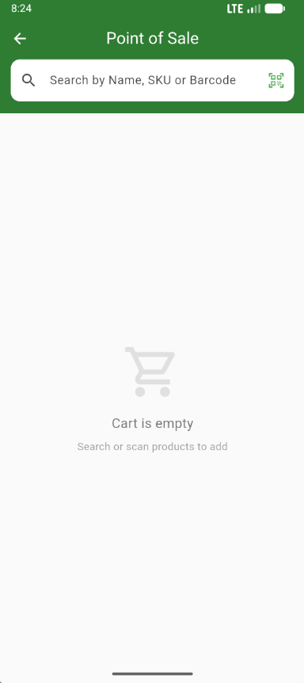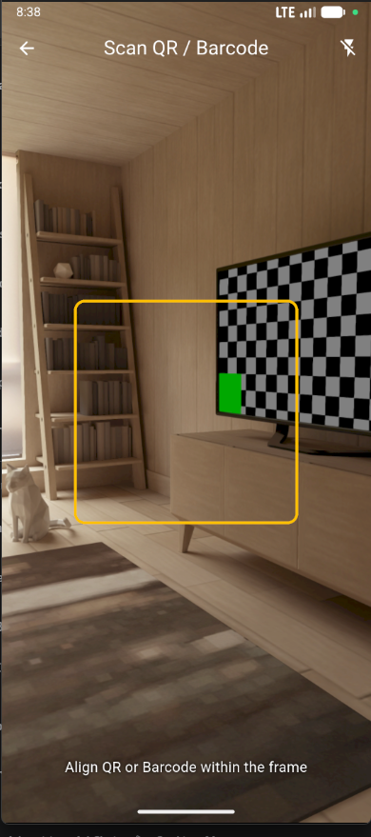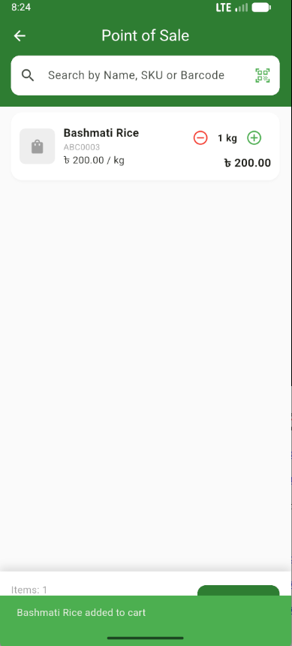
- The PDF Invoice / Receipt Preview
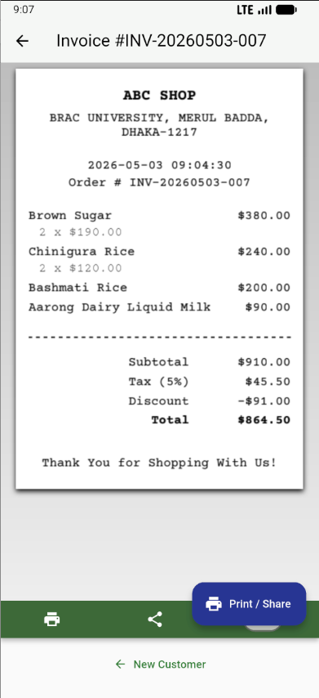

- The Owner/Manager Analytics Dashboard
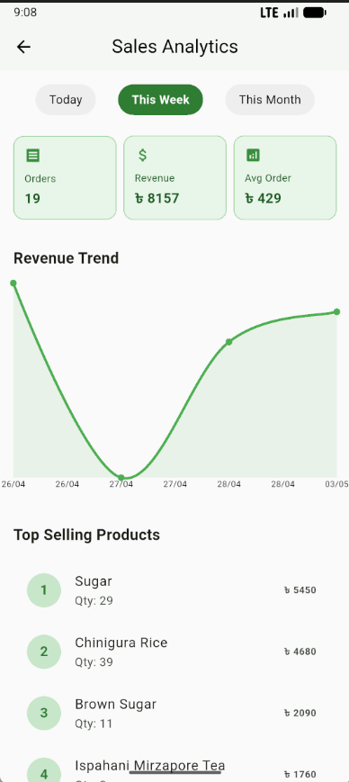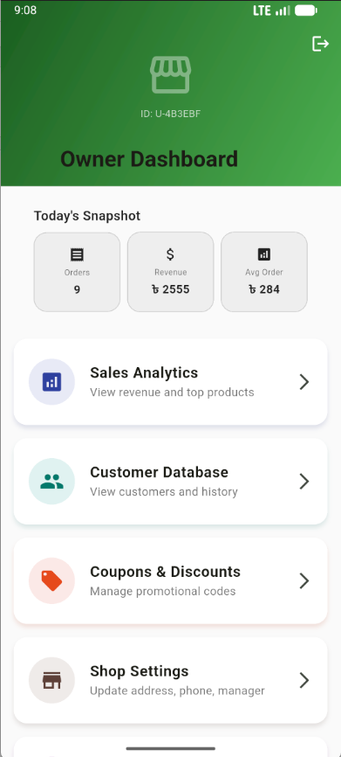
- The Low-Stock Alerts Screen
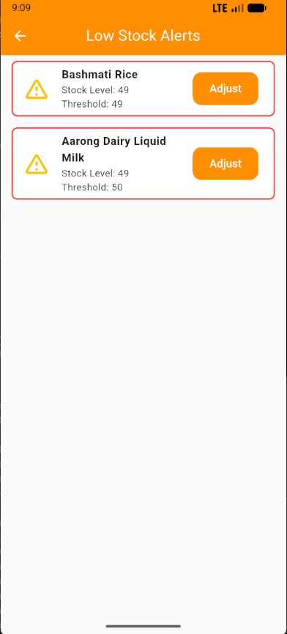

- The Product Management List
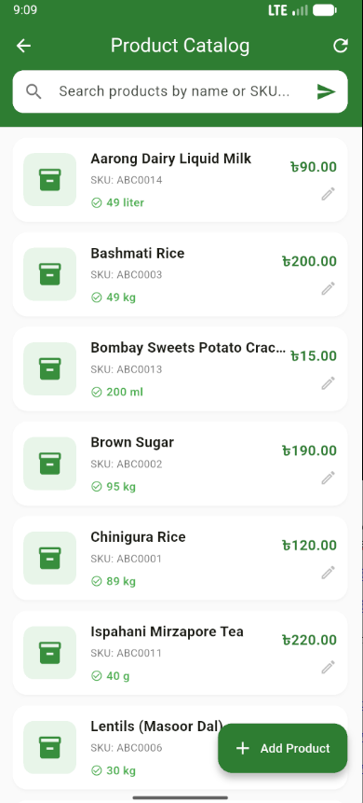

Online Resources used:
a) Reference:
- flutter.dev and pub.dev (for package documentation like mobile_scanner, pdf, provider)
  - https://pub.dev/packages/pdf
  - https://pub.dev/packages/printing
- expressjs.com and mongoosejs.com (for backend API development)
- Youtube videos:
  - https://youtu.be/CzRQ9mnmh44?si=haymMeWaMNkMELGM
  - https://www.youtube.com/watch?v=uSljGJGSl6w
  - https://www.youtube.com/watch?v=622vOT8A1J0

b) Stackoverflow or github links.
- Stackoverflow for debugging Flutter layout issues and MongoDB aggregation queries.
- GitHub documentation:
  - https://github.com/juliansteenbakker/mobile_scanner
  - https://github.com/DavBfr/dart_pdf

Future Enhancements:
Following enhancement can be added to the current system which will improve the system.

- Multi-Branch Synchronization: Allowing super-admins to manage centralized inventory pushed out to multiple localized retail branches.
- Offline Mode: Enabling the POS system to function without an internet connection and seamlessly syncing transactions to the backend once the connection is restored.
- AI Sales Forecasting: Using historical transaction data to predict future sales trends and automatically suggest restock quantities.
- Customer Loyalty Program: A point-based reward system integrated into the checkout process based on a customer's total spent history.
- Supplier & Purchase Orders: A dedicated module to track suppliers, generate purchase orders, and automatically log incoming deliveries into the inventory.

